NAME : Arjun Sehgal , Akshit Shah, Vatsal Shah

Roll : 1811041, 1811042, 1811052

Subject : OSPTL

TOPIC : HOSPITAL MANAGEMENT SYSTEM (USING TKINTER )

**DESCRIPTION :**

**The system has four functionalities:**

1)Add an appointment

2)Update an appointment

3)Delete an appointment

4)view the appointment

**There are TOTAL 3 different window connected with MASTER.py ( MASTER IS THE MAIN WINDOW)**

1)ADD appointment

2)UPDATE and DELETE appointment

3)View appointment

**HOW TO USE THE SYSTEM :**

STEP 1) RUN THE MASTER.py :

OUTPUT : This will open a login window

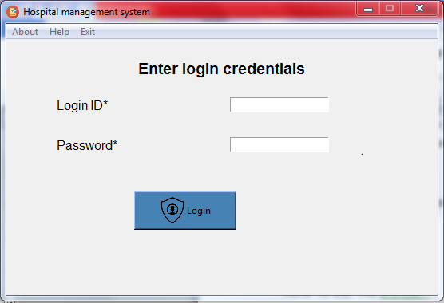

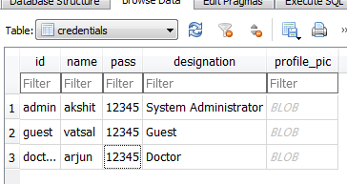

This is the database table used for loggin :

STEP 2 :LOGIN with any of the credential given in the database table

HERE logged in as arjun

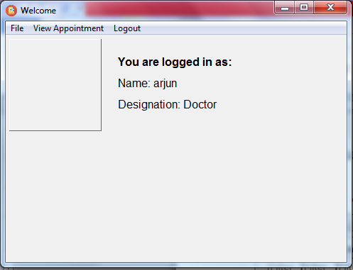

TOTAL FUNCTIONALITES ARE GIVEN IN FILE

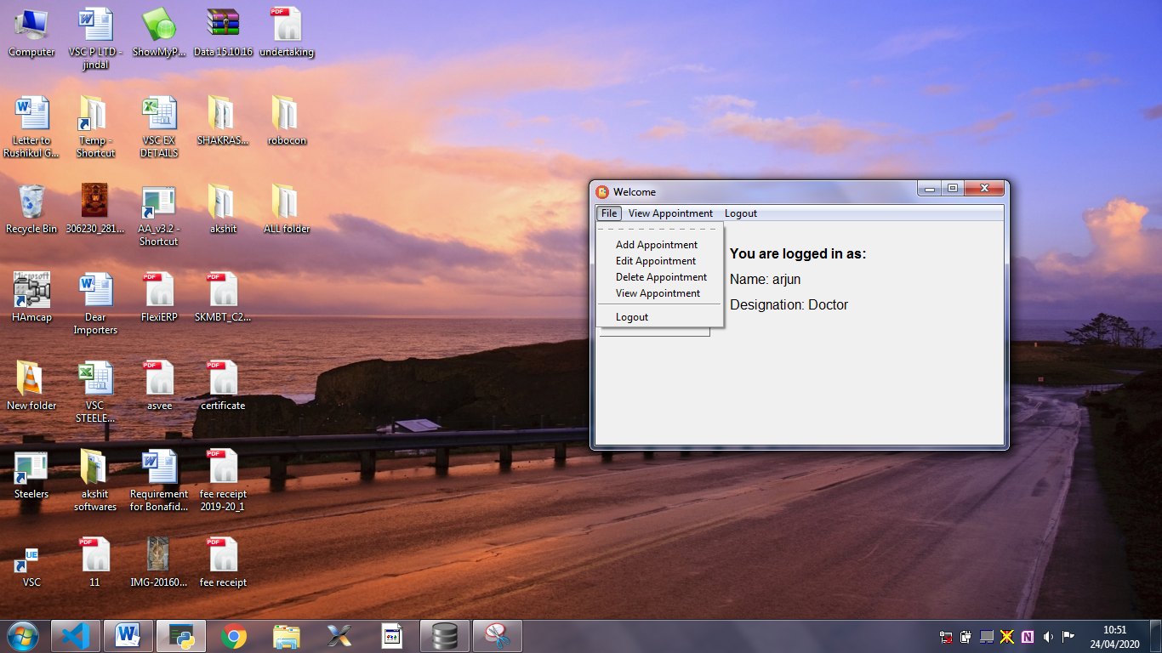

ADD APPOINTMENT WINDOW:

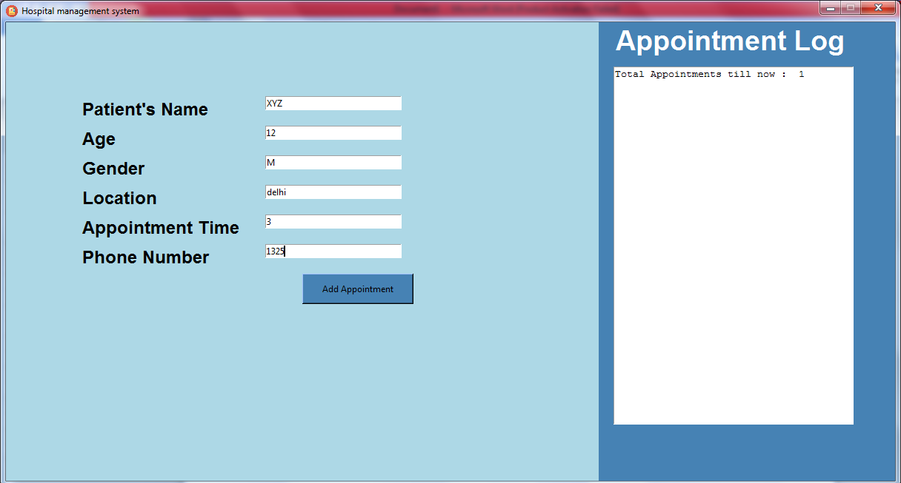

CLICK Add appointment :

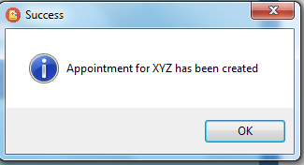

The data stored in appointments table :

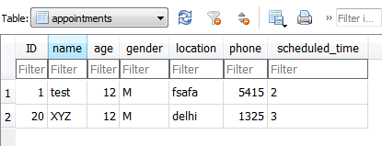

UPDATE/DELETE window:

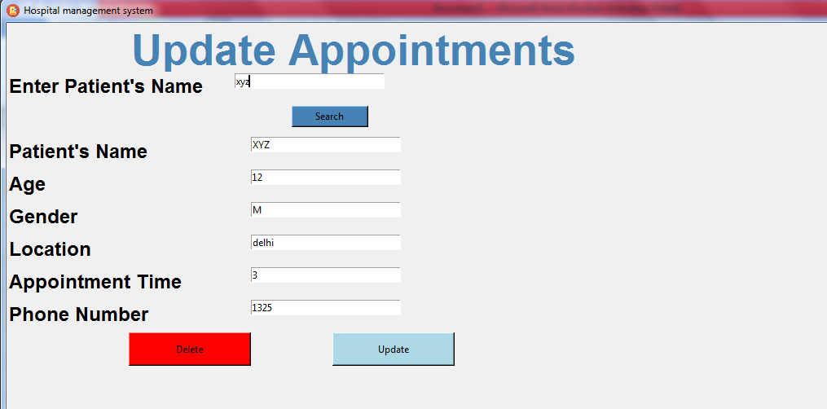

Changed appointment time to 5 and age to 13

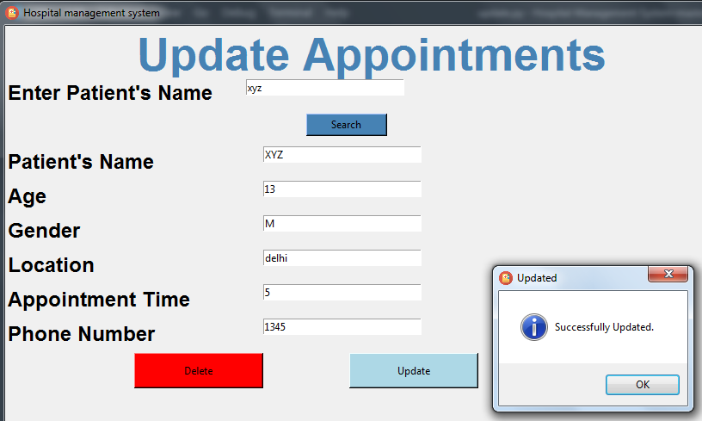

DATABASE UPDATED :

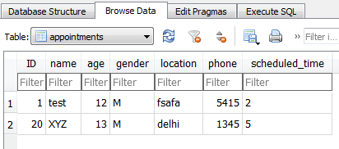

The ID is 20 because it is auto incremented forever, and while testing we had created and deleted between 18 accounts. But now it is again reset to 1.

Appointments Page :

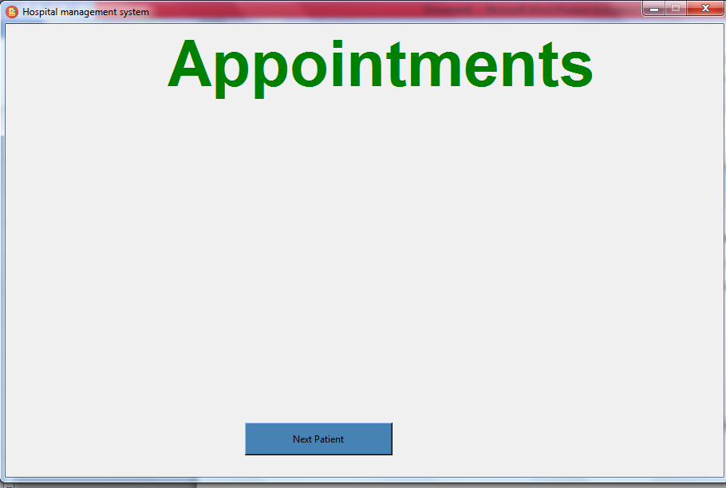

CLICK ON NEXT :

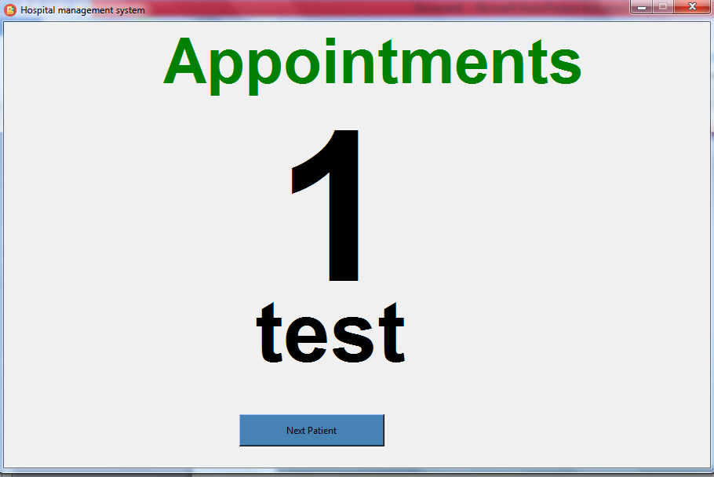

CLICK ON NEXT ;

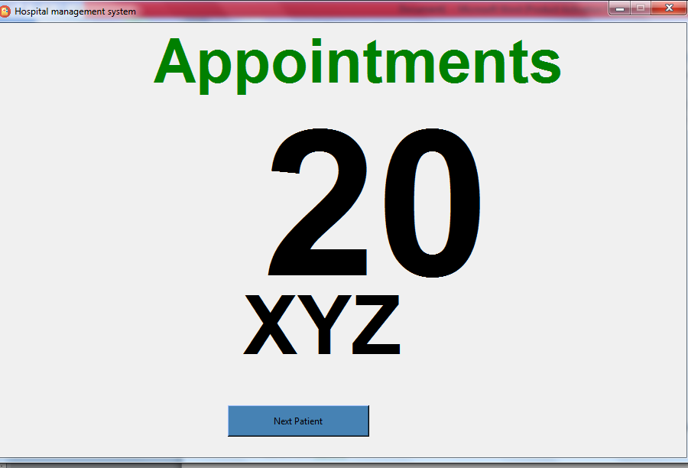

DELETING an Appointment :

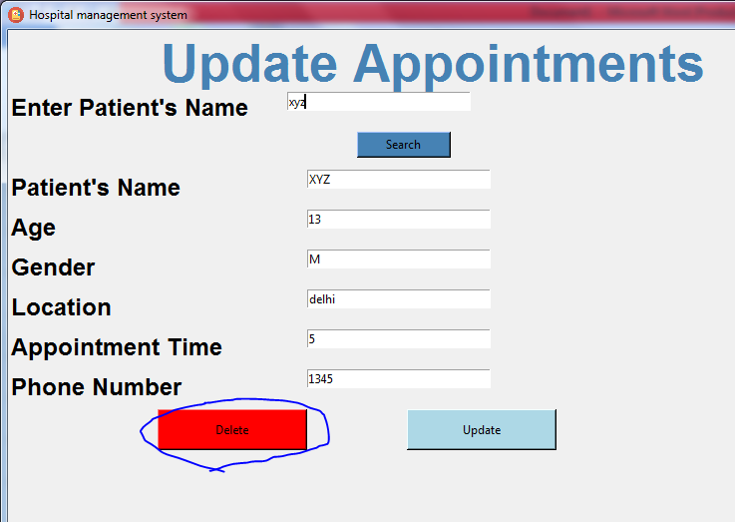

Also deleted from database :

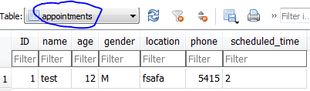

**Libraries used :**

tkiner : for GUI

os : to open new windows

sqlite3 : for connection database

pyttsx3 : for speaking the appointments (it works only if all the modules are properly supported in the device )

PIL : used to show the image of the user. (But its not yet working)

**SOFTWARES USED :**

1. Visual studio code : To write code
2. DB browser ( SQlite) : To operate DATABASE